**WEB222 Assignment1**

Due: Friday, Sep 21th, 2019 @ 11:59 pm

# **Task 1: student Info (use your information)**

## a) Store the following information in variables:

* Student name: **Youjin An**
* Number of courses: 5
* Program: Computer programming and analysis (CPA)
* Having a part-time job: False

## b) Output your student info to the browser console as:

* "My name is ??? and I’m in ??? program. I’m taking ??? course in this semester."

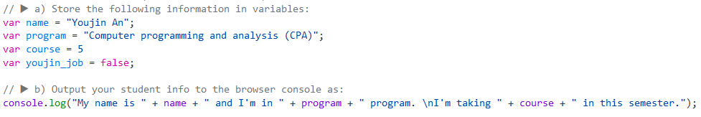



## C) Store the string “have” or “don’t have” into a variable based on the value of the variable storing whether or not you have a part‐time job (true/false).

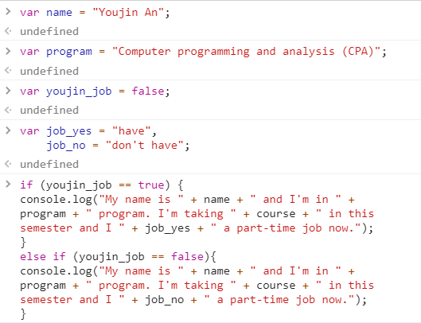

## d) Output your updated student info to the console as:

* "My name is ??? and I’m in ??? program. I’m taking ??? course in this semester and I ??? a part‐time job now."

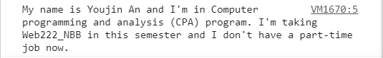

# **Task 2: birth and grauate year**

## a) Store the current year in a variable. [1 mark]



## b) Prompt to user “Please enter your age:” and store the input value in a variable. [1 mark]



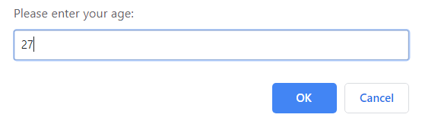

## c) Output the birth year to the console as: "You were born in the year of ???." [1 mark]

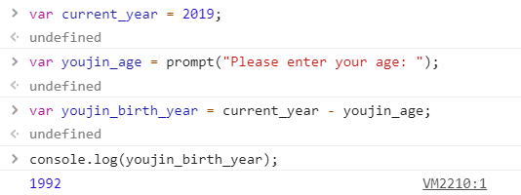

## d) Prompt to user “Enter the number of years you expect to study in the college:” and store the input value in a variable. [1 mark]



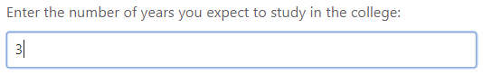

## e) Output the graduate year to

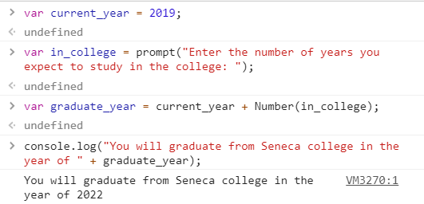

# **Task 3: Celsius and Fahrenheit temperatures**

## a) Store a Celsius temperature in a variable. [1 mark]



## b) Convert it to Fahrenheit and output: "???°C is ???°F". [1 mark]

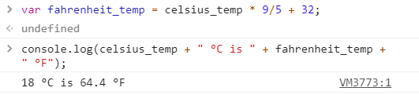

## c) Store a Fahrenheit temperature into a variable. [1 mark]



## d) Convert it to Celsius and output: "???°F is ???°C." [1 mark]

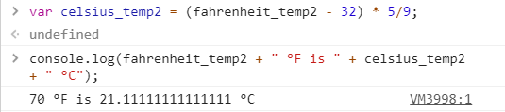

# **Task 4: Even and odd numbers**

## a) Write a for loop that will iterate from 0 to 10. For each iteration, your code should check if the current number is even or odd, and output that information to the browser console (e.g. "5 is odd").

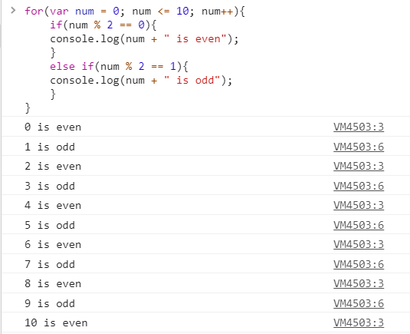

# **Task 5: Larger or largest number**

## a) Write a function named largerNum using the declaration approach, the function: takes 2 arguments, both numbers, returns the larger (greater) one of the 2 numbers. [3 marks]

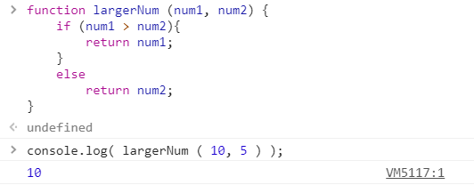

## b) Call this function twice with different number parameters, and log the output to the web console with descriptive outputs each time (e.g. "The larger number of 5 and 12 is 12.").

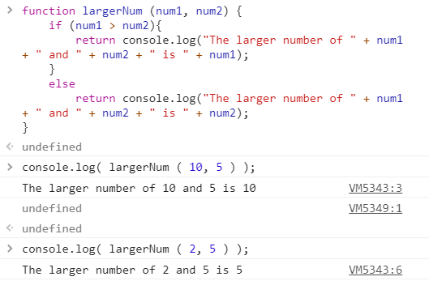

# **Task 6: evaluator**

## a) Write a function named evaluator using the declaration approach, the function: takes unknown number of arguments which are all number scores, returns true if the average of these number scores is greater than or equal to 50. Otherwise return false.

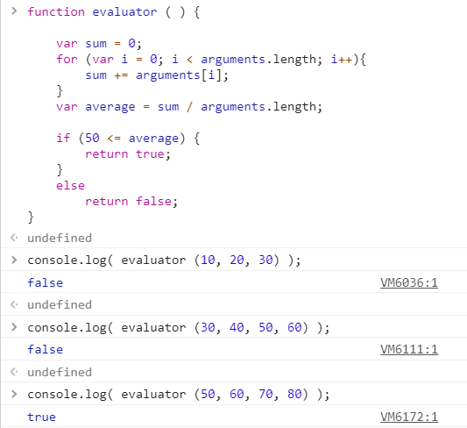

## b) Call this function 3 times with different number parameters, and log the output to the web console with descriptive outputs each time (e.g. “Average grater than or equal to 50: false”);

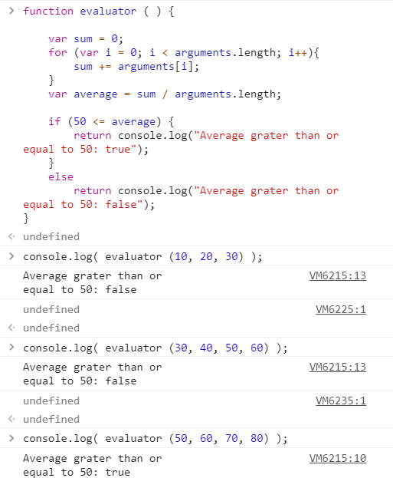

# **Task 7: Grader**

## a) Write a function named Grader using the expression approach, the function: takes a single argument which is a number mark,

## returns a grade for the mark ‐ "A", "B", "C", "D", or "F".

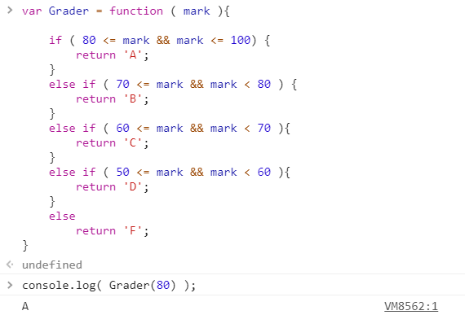

## b) Call this function 3 times with different number marks, and log the output to the web console with descriptive outputs each time (e.g., “mark 89, grade is A”)

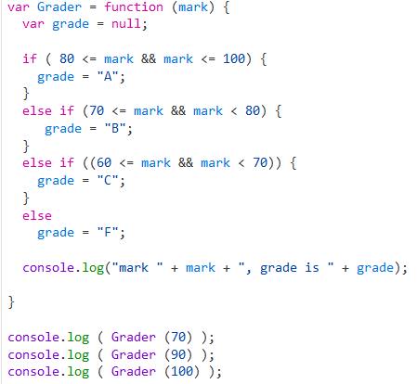

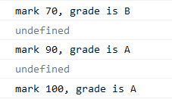

# **Task 8: ShowMultiples**

## a) Write a function called showMultiples using the declaration approach, the function: Takes 2 numeric arguments (num, numMultiples) – assume the user is entering valid (positive) whole numbers

## Outputs all of the multiples of the num argument from 1 to numMultiples:

## for example:

## if num = 5 and numMultiples = 4, the function would output:

## 5x1=5

## 5 x 2 = 10

## 5 x 3 = 15

## 5 x 4 = 20

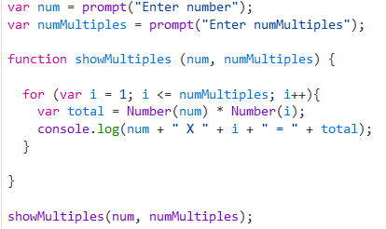

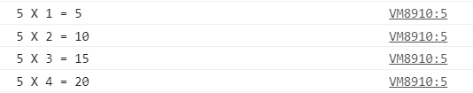

## b) Call this function 3 times with different number parameters, and log the output to the web console with descriptive outputs

